I
Idlewild

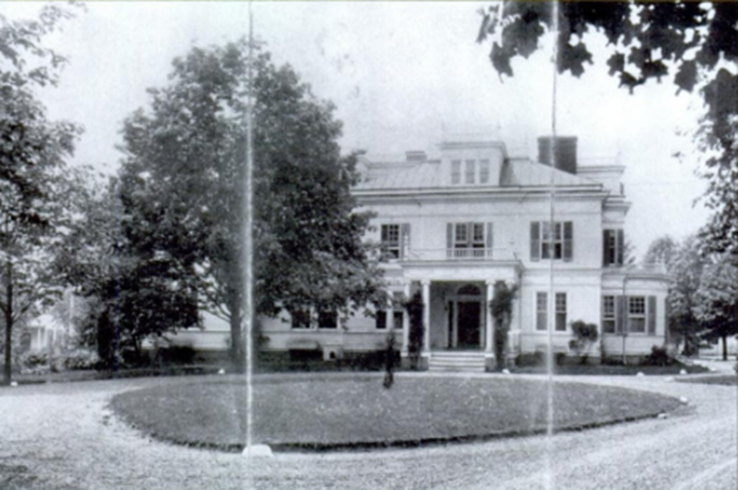

Location: In the vicinity of present-day Idlewild Drive in Morris Plains, New Jersey.
Built: c.1890.
History
It was built in the 1890s and became the temporary home of Louis Andrew Thebaud while his grander house, Beauregard, was being built. In the 1920s Idlewild was purchased by Lewis Grove and became his development’s country club. It burned to the ground in 1925 after an American Legion party.

Islecote House
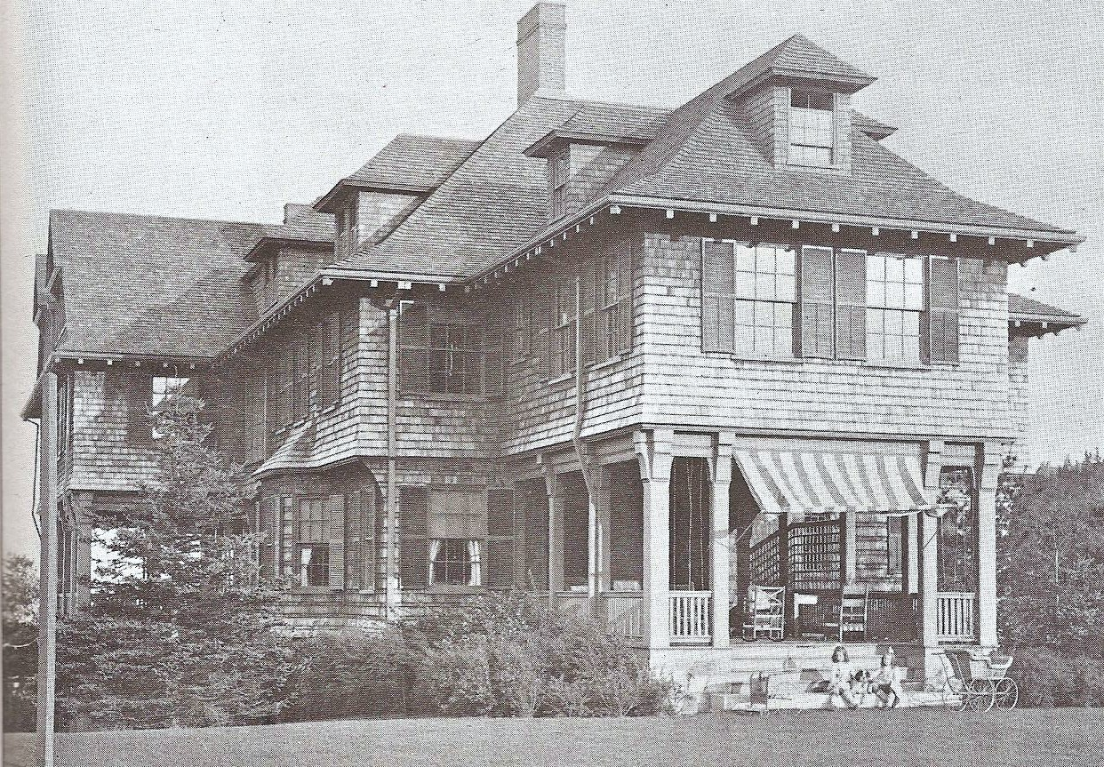
Location: Pointe d'Acadie on the Vanderbilt estate in Bar Harbor, Maine.
Built: 1902
Architect: Alexander Wadsworth Longfellow, nephew of the poet

Architect
Alexander Wadsworth Longfellow Jr. (1854–1934), affectionately known as "Waddy," was a prominent American architect based in Boston and the nephew of the renowned poet Henry Wadsworth Longfellow. Born on August 18, 1854, in Portland, Maine, to Alexander Wadsworth Longfellow Sr. (the poet's brother) and Elizabeth Porter Longfellow, he grew up immersed in a family legacy of intellectual and artistic achievement. After graduating from Harvard University in 1876, he pursued architectural training at the Massachusetts Institute of Technology before studying at the prestigious École des Beaux-Arts in Paris, where he honed his skills under influential mentors and absorbed European styles, particularly French Romanesque. Upon returning to the United States, Longfellow became a leading figure in the Romanesque Revival and Shingle Style movements, designing numerous grand summer "cottages" along the Maine coast—including works in Bar Harbor such as Islecote House—as well as institutional buildings, residences, and civic structures in Boston and beyond. He co-founded the Boston Society of Architects and practiced independently or in partnerships, blending picturesque, site-sensitive designs with high craftsmanship using local materials like shingles and granite.
Architectural Description
Spanning over 20,000 square feet, Islecote measured approximately 45 by 127 feet and was oriented east-west with its front facing south. The design was irregular and picturesque, featuring a four-story structure (including basement and attic) with an overhanging second story. The first floor used local pink granite ashlar with warm, varied colors and large joints for a rustic yet elegant base, while upper levels incorporated half-timbering, pebble-dash stucco, and shingles. A steep hip roof with multiple ridges and gables added to its dynamic silhouette. The house gained recognition shortly after completion, being featured in publications like The American Architect for its innovative blend of materials and style.

History
Islecote House was a notable summer cottage located on the Pointe d'Acadie estate in Bar Harbor, Maine, part of the larger Vanderbilt family holdings during the Gilded Age. Built in 1901-1902 by George Washington Vanderbilt II specifically for his niece, Louise Vanderbilt Shepard (married to William Jay Schieffelin), it served as a seasonal residence for the Schieffelin family.
The broader Pointe d'Acadie estate, originally known as Watersmeet, was constructed in 1868-1869 for Governor Morris Ogden before Vanderbilt acquired it in 1889. Vanderbilt renamed it Pointe d'Acadie and enlisted landscape architect Frederick Law Olmsted to enhance the grounds, adding winding roads, strategic tree plantings, a stone terrace with stairs leading to the main shingled residence, and even damming a small cove to form Bar Harbor's first naturalistic swimming pool. This transformed the property into a serene retreat overlooking Gilpatrick's Cove, aligning with the Vanderbilt family's preference for understated luxury in Bar Harbor compared to their more ostentatious Newport estates. Islecote was added as a secondary structure on the estate to accommodate family members, reflecting the era's trend of building "cottages" that were actually grand homes for the elite.
Ten horses were stabled there so the whole family could ride. One of Bar Harbor's favorite sights was the entire Schieffelin family riding out the gate on horseback, each young Schiefflin on a successively smaller horse, with the youngest bringing up the rear on a pony.
The Schieffelins used Islecote as their summer home, and it later saw notable tenants, including Madeleine Force Astor (widow of John Jacob Astor IV, who perished on the Titanic), who rented it briefly after initially staying at another nearby property. The estate as a whole was a hub for high society, though Bar Harbor's summer colony began declining in the early 20th century due to economic shifts and events like the 1947 fire that devastated much of the area.
Islecote was demolished in 1940, and the main Pointe d'Acadie house followed in 1952, as many such Gilded Age properties fell into disrepair or were subdivided amid changing tax laws and the Great Depression. Today, the site remains privately owned, with remnants of Olmsted's landscape design preserved, though no structures from the Vanderbilt era stand.

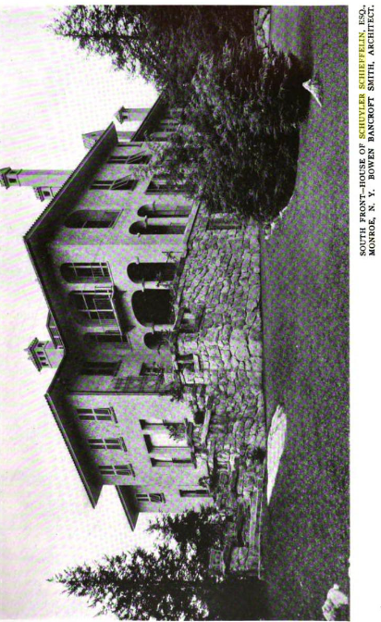
Islesmere Farm, now Arrow Park

Location: 1061 Orange Turnpike, Monroe, New York.
Built: 1909.
Architect: Bowen Bancroft Smith.

Architect
Bowen Bancroft Smith (1869–1932) was a Beaux-Arts–trained architect whose work was closely associated with the country-house culture of New York’s elite in the early twentieth century. Educated at the Massachusetts Institute of Technology and the Atelier Paul Blondel in Paris, Smith brought formal academic training to the design of large suburban and rural estates, often blending Italianate and French Renaissance forms with Arts and Crafts influences. Early in his career he was a partner in the New York firm of Welch, Smith & Provot, which produced prominent Beaux-Arts residences on Manhattan’s Upper East Side for families such as the Halls and Dukes. Practicing independently after 1900, Smith designed numerous country houses in Tuxedo Park and the Hudson Valley, including the 1909 Schieffelin estate at Islesmere Farm (later Arrow Park), noted for its dramatic siting, textured materials, and richly articulated interiors. Though never as widely known as the largest architectural firms of his era, Smith was respected among contemporaries for his refined planning, decorative interiors, and ability to adapt academic design principles to picturesque American landscapes.

Architectural description
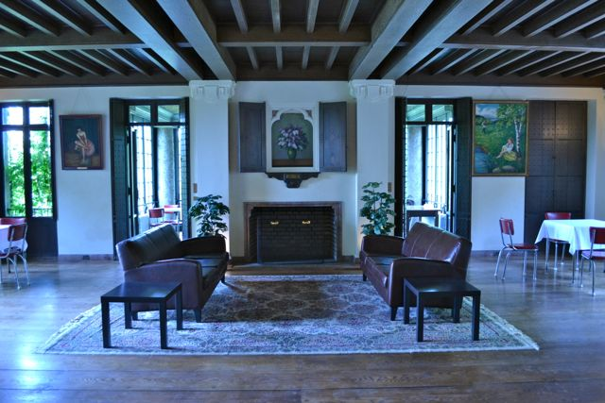
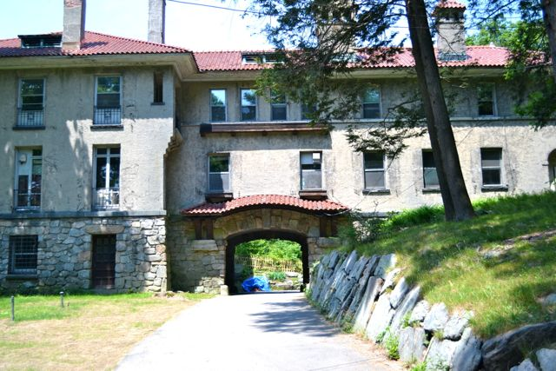
Smith designed the main residence as an Italianate villa incorporating Arts and Crafts influences, with an emphasis on massing, textured surfaces, and carefully articulated interiors. Contemporary architectural journals noted the estate for its decorative interior treatments, including experimental concrete wall finishes.
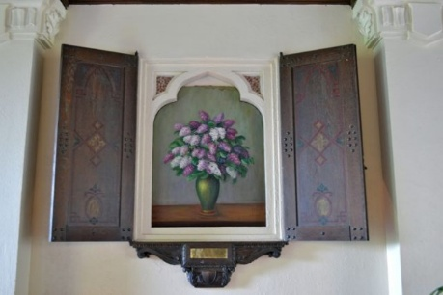

Islesmere Farm was developed in the early twentieth century as a country estate in Monroe, Orange County, New York. The property occupies a bowl-shaped hollow overlooking a small lake along what is now Orange Turnpike (Route 17M), a setting deliberately chosen for its pastoral and picturesque qualities.
The estate was created in 1909 by Schuyler Schieffelin and his wife Julia Cooper Schieffelin, a member of the Cooper family associated with Cooper Union in New York City. The Schieffelins purchased the land from railroad magnate E. H. Harriman.
Alongside its function as a summer residence, the property operated as a working dairy farm, known as Islesmere Farm, producing milk and farm goods; surviving dairy artifacts bearing the Islesmere name attest to this phase of its history.
The Schieffelin family retained the property through the early decades of the twentieth century, using it as both a retreat and an expression of Gilded Age pastoral idealism. By the 1940s, however, changing social and economic conditions led to a dramatic transformation in the estate’s use.
In 1948, the property was purchased by a cooperative of New York City–based immigrant workers associated with the American Russian Organized Workers (AROW). Pooling their resources, the families acquired the house and grounds as a collective summer retreat and cultural center. Under cooperative ownership, the estate was renamed Arrow Park. Families rotated summer stays and shared responsibility for maintenance, agriculture, and daily operations. Remarkably, little was altered architecturally during this period, preserving much of the original house and landscape.
In the 1970s, a trust acquired the property, buying out the remaining cooperative members. The estate returned to private management while retaining its historic fabric. In the late twentieth and early twenty-first centuries, Arrow Park evolved into a retreat, event venue, and bed-and-breakfast, gaining recognition as one of the Hudson Valley’s most intact early twentieth-century country estates. The house and grounds have also served as filming locations and continue to be valued for their architectural integrity and layered social history.

